The Des Moines Public Schools Curriculum guide contains the prioritized standards, required pacing, materials and resources, and assessment correlates for the school year. This document is intended to be used in conjunction with our balanced assessment plan to scaffold our students in mastery of the Iowa Core State Standards.

**College US History: Des Moines Public Schools**

2017-18 CURRICULUM GUIDE SOC521A/522A

|  |
| --- |
| **College AP United States History** |
| The AP United States History course is equivalent to an introductory college-level course in U.S. history. This course develops students’ abilities to think conceptually about U.S. history from approximately 1491 to the present and apply historical thinking skills as they learn about the past. Seven themes of equal importance – identify; peopling; politics and power; work, exchange, and technology; America in the world; environment and geography; and ideas, beliefs, and culture – provide areas of historical inquiry for investigation throughout the course. These require students to reason historically about continuity and change over time and make comparison among various historical developments in different times and places.  **AP United States History** **– Course Content:**  • Period 1: 1491-1607 • Period 2: 1607-1754 • Period 3: 1754-1800 • Period 4: 1800-1848  • Period 5: 1844-1877 • Period 6: 1865-1898 • Period 7: 1890-1945 • Period 8: 1945-1980 • Period 9: 1980-Present  **AP United States History – Historical Thinking Skills:**  • Chronological Reasoning  • Comparison and Contextualization  • Crafting Historical Arguments from Historical Evidence  • Historical Interpretation and Synthesis  **AP United States History** **Exam**  The AP United States History Exam measures students’ knowledge of U.S. history and their ability to think historically.  **Format of Assessment**  **Section I Part A: Multiple Choice | 50-55 Questions | 55 Minutes | 40% of Exam Score**  • Questions appear in sets of 2-5 • Students analyze historical texts, interpretations, and evidence • Primary and secondary sources, images, graphs, and maps are included  **Section I Part B: Short Answer | 4 Questions | 45 Minutes | 20% of Exam Score**  • Questions provide opportunities for students to demonstrate what they know best • Some questions include texts, images, graphs, or maps  **Section II Part A: Document-Based | 1 Question | 60 Minutes | 25% of Exam Score**  • Analyze and synthesize historical data • Assess written, qualitative, or visual materials as historical evidence  **Section II Part B: Long Essay | 1 Question | 35 Minutes | 15% of Exam Score**  • Students select one of two questions • Explain and analyze significant issues in U.S. History • Develop an argument supported by an analysis of historical evidence  **Link to Course Information @ AP Central:** <https://advancesinap.collegeboard.org/english-history-and-social-science/us-history> |

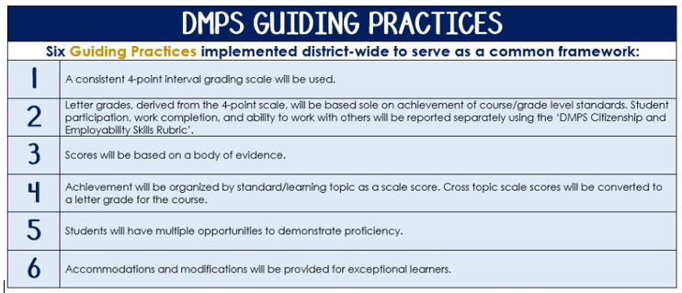

**Standards-Referenced Grading Basics**

The teacher designs instructional activities and assessments that grow and measure a student’s skills in the elements identified on our topic scales. Each scale features many such skills and knowledges, also called learning targets. These are noted on the scale below with letters (A, B, C) and occur at Levels 2 and 3 of the scale. In the grade book, a specific learning activity could be marked as being 3A, meaning that the task measured the A item at Level 3.

|  |
| --- |
| **The Body of Evidence in a Process-Based Course** |
| **Process-Based SRG** *is defined as an SRG course design where the same scale recurs throughout the course, but the level of complexity of text and intricacy of task increase over time.*  College AP US History does not have a traditional unit-based design. Instead, students cycle through the same basic topics repeatedly as they progress through the course, with changing content and an increasing complexity of the text, analysis, and writing expectations throughout.  To account for this, process-based courses like this have their evidence considered in a “Sliding Window” approach. When determining the topic score for any given grading topic, *the most recent evidence* determines the topic score. Teacher discretion remains a vital part of this determination, but it is hard to overlook evidence from the most recent (and therefore rigorous) assessments. |

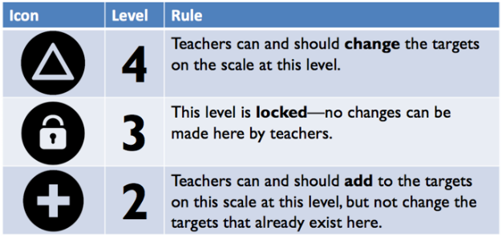

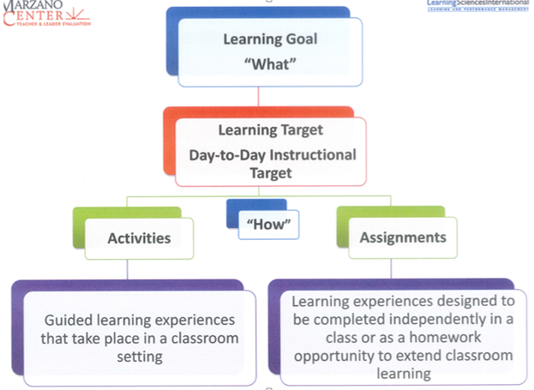

|  |  |
| --- | --- |
| College AP United States History Topics | |
| **Text and Resources** | |
| Course Text:  *Give Me Liberty! An American History, 3rd Edition.*  Eric Foner | AP Teacher Community: <https://apcommunity.collegeboard.org/web/apushistory> |
| Scales | |
| |  |  |  |  | | --- | --- | --- | --- | | **Topic** | **4** | **3** | **2** | | **Chronological Reasoning** | 4A: Causation- Evaluate the relative significance of different causes and/or effects, considering primary/secondary and/or long- and short-term causes/effects  4B: Continuity/Change over Time (CCOT)-Assess competing patterns of historical continuities and changes over periods of time; assess the relative historical significance of specific developments in relation to a larger pattern of continuity and/or change | 3A: Causation-Explain relationships between causes/effects of specific historical developments or processes; explain the difference in historical significance between primary and secondary causes/effects and between long- and short-term causes/effects  3B: Continuity/Change over Time (CCOT)-Explain patterns of historical continuities and changes over periods of time; explain relative historical significance of specific developments in relation to a larger pattern of continuity and/or change | 2A: Causation-Describe causes/effects of historical developments or processes  2B: Continuity/Change over Time (CCOT)-Describe historical continuities and changes over time | | **Topic** | **4** | **3** | **2** | | **Comparison and Contextualization** | 4A: Comparison-Investigate the reasons for the similarities and differences of multiple sources and types  4B: Comparison-Evaluate relative historical significance of similarities and differences across multiple events, development or processes and the reasons for those  4C: Contextualization- Draw conclusions about the relative significance of historical events, developments, or processes within the broader regional, national, or global context in which they occurred | 3A: Comparison-Compare and contrast multiple sources and types and explain their historical significance  3B: Comparison-Compare and contrast historical events, developments, or processes and explain their historical significance  3C: Contextualization-Situate historical events, developments, or processes within the broader regional, national, or global context in which they occurred | 2A: Comparison-Identify similarities or differences between sources and/or  2B: Comparison-Identify similarities or differences between historical events, developments, or processes  2C: Contextualization-Explain ways in which historical events, developments, or processes occur within a broader regional, national, or global context | | **Topic** | **4** | **3** | **2** | | **Historical Source Interpretation** | 4A: Critique the credibility and historical significance of an historical perspective utilizing how the argument has been supported in relation to the author’s point of view, purpose, audience, and/or historical situation  4B: Critique competing arguments or understanding of historical events, developments or processes; evaluate the relative significance of patterns and trends | 3A: Analyze the credibility and historical significance of an historical perspective utilizing how the argument has been supported in relation to the author’s point of view, purpose, audience, and/or historical situation  3B: Analyze diverse historical interpretations; analyze patterns and trends in multiple source | 2A: Describe relevant information and/or arguments of a source; identify patterns or trends in quantitative data  2B: Identify diverse historical interpretations; identify patterns or trends in multiple sources | | **Topic** | **4** | **3** | **2** | | **Creating & Supporting an Argument from Evidence** | 4A: Articulate a defensible claim that incorporates historical knowledge and sources while it critiques multiple factors with a diversity of supports  4B: Evaluates disparate, diverse or contradictory evidence to explain its relevance to a claim  4C: Evaluate historical evidence in a cohesive way to illustrate contradiction, corroboration, qualification and historical relationships in an argument | 3A: Articulate a historically defensible claim that evaluates the relative importance of multiple factors in a thesis  3B: Use historical reasoning to explain disparate, diverse or contradictory evidence or perspectives  3C: Utilize diverse historical evidence in a cohesive way to qualify or modify an argument | 2A: Introduce a defensible claim that acknowledges multiple factors in a thesis  2B: Provide evidence to support the claim  2C: Provide multiple pieces of evidence | | **Topic** | **4** | **3** | **2** | | **Key Concepts** | Synthesize understandings of content-specific key ideas, people, events and developments from each historical period. | Apply and analyze content-specific key ideas, people, events and developments from each historical period. | Identify and explain content-specific key ideas, people, events and developments from each historical period. | | **Topic** | **4** | **3** | **2** | | **Writing for AP** | *A level 4 writing sample achieves a-d, depending on type of writing (LEQ, DBQ)*  4A: Thesis-historically defensible claim that answers all parts of the question and creates a cohesive argument that recognizes and accounts for historical complexity by demonstrating relationships among evidence such as contradiction, corroboration and/or qualification  4B: Describes a broader historical context relevant to the prompt  4C: **Option 1 DBQ -**  Utilizes content of at least 6 documents to support an argument in response to the prompt  **Option 2 LEQ -** Supports an argument in response to the prompt using specific and relevant examples of evidence  4D: **Option 1 DBQ** - supports argument and explains significance of author’s point of view, purpose, historical context and/or audience for at least 3 documents; accounts for historical complexity by demonstrating relationships among evidence such as contradiction, corroboration and/or qualification  **Option 2 LEQ -** Demonstrates a complex understanding of the historical development that is the focus of the prompt, using evidence to corroborate, quality, or modify an argument that addresses the question. | *A level 3 writing sample demonstrates* ***a****, and two other options (b, c, or d) depending on type of writing (LEQ, DBQ)*  3A: Thesis-historically defensible claim that answers all parts of the question and creates a cohesive argument that recognizes and accounts for historical complexity by demonstrating relationships among evidence such as contradiction, corroboration and/or qualification  3B: Describes a broader historical context relevant to the prompt  3C: **Option 1 DBQ**: Utilizes content of at least 6 documents to support an argument in response to the prompt  **Option 2 LEQ:** Supports an argument in response to the prompt using specific and relevant examples of evidence  3D: **Option 1 DBQ** - supports argument and explains significance of author’s point of view, purpose, historical context and/or audience for at least 3 documents; accounts for historical complexity by demonstrating relationships among evidence such as contradiction, corroboration and/or qualification  **Option 2 LEQ** - Demonstrates a complex understanding of the historical development that is the focus of the prompt, using evidence to corroborate, quality, or modify an argument that addresses the question. | *A level 2 writing sample demonstrates* ***a*** *and one other option (b, c, or d) depending on type of writing (LEQ, DBQ)*  2A: Thesis-historically defensible claim that answers all parts of the question and creates a cohesive argument that recognizes and accounts for historical complexity by demonstrating relationships among evidence such as contradiction, corroboration and/or qualification  2B:Describes a broader historical context relevant to the prompt  2C: **Option 1 DBQ -**Utilizes content of at least 6 documents to support an argument in response to the prompt  **Option 2 LEQ:** Supports an argument in response to the prompt using specific and relevant examples of evidence  2D: **Option 1 DBQ** - supports argument and explains significance of author’s point of view, purpose, historical context and/or audience for at least 3 documents; accounts for historical complexity by demonstrating relationships among evidence such as contradiction, corroboration and/or qualification  **Option 2 LEQ –** Demonstrates a complex understanding of the historical development that is the focus of the prompt, using evidence to corroborate, quality, or modify an argument that addresses the question. | | |