The Des Moines Public Schools Curriculum guide contains the prioritized standards, required pacing, materials and resources, and assessment correlates for the school year. This document is intended to be used in conjunction with our balanced assessment plan to scaffold our students in mastery of the Iowa Core State Standards.
AP Human Geography: Des Moines Public Schools
2017-18 CURRICULUM GUIDE SOC 519/520

AP Human Geography
The AP Human Geography course is equivalent to an introductory college-level course in human geography. Our driving question for the course is “How does where you live affect you live?” The course introduces students to the systematic study of patterns and processes that have shaped human understanding, use, and alteration of Earth’s surface. Students employ spatial concepts and landscape analysis to examine socioeconomic organization and its environmental consequences. They also learn about the methods and tools geographers use in their research and applications. The curriculum reflects the goals of the National Geography Standards.
Social Studies Weebly: socialstudies.dmschools.org DMPS Grading Resources: grading.dmschools.org

Goals of AP Human Geography Upon successful completion of the course, students will be able to:
• Interpret maps and analyze geospatial data;
• Understand and explain the implications of associations and networks among phenomena in places;
• Recognize and interpret the relationships among patterns and processes at different scales of analysis;
• Define regions and evaluate the regionalization process; and
• Characterize and analyze changing interconnections among places.

Topic Outline for AP Human Geography, the AP Human Geography course is organized around seven major topics:
- Geography: Its Nature and Perspectives
- Population and Migration
- Cultural Patterns and Processes
- Political Organization of Space
- Agriculture, Food Production, and Rural Land Use
- Industrialization and Economic Development
- Cities and Urban Land Use
AP Human Geography Exam
The AP Human Geography Exam requires students to explain and apply key and supporting geographical concepts. The exam employs multiple-choice questions and free-response questions based on components of the seven major curriculum topics. Students must be able to define, explain, and apply geographical concepts and interpret geographical data.
Format of Assessment Section I: Multiple Choice | 75 Questions | 60 Minutes | 50% of Exam Score
• Define, explain, and apply geographic concepts • Interpret geographic data
Section II: Constructed Response | 3 Questions | 75 Minutes | 50% of Exam Score
• Synthesize different topical areas • Analyze and evaluate geographical concepts • Supply appropriately selected and well-explained real-world examples to illustrate geographic concepts • Interpret verbal descriptions, maps, graphs, photographs, and/or diagrams • Formulate responses in narrative form
Link to Course Information @ AP Central: http://apcentral.collegeboard.com/apc/public/courses/teachers_corner/8154.html
 | Unit | Enduring Understandings | Content Topics
 | Unit 1  Population and Migration | - Knowledge of the geographic patterns and characteristics of human populations facilitates understanding of cultural, political, economic, and urban systems.  - Populations grow and decline over time and space.  - Causes and consequences of migration are influenced by cultural, demographic, economic, environmental, and political factors. | - Population Analysis  - Migration
 | Unit 2  Cultural Patterns and Processes | - Concepts of culture frame the shared behaviors of a society.  - Culture varies by place and region. | - Concepts of Culture  - Cultural Identity and Cultural Differences
 | Unit 3  Political Organization of Space | - The contemporary political map has been shaped by events of the past.  - Spatial political patterns reflect ideas of territoriality and power at a variety of scales.  - The forces of globalization challenge contemporary political–territorial arrangements. | - Political Patterns and Organization  - Cooperation and Conflict
 | Unit 4  Agriculture | - The development of agriculture led to widespread alteration of the natural environment.  - Major agricultural regions reflect physical geography and economic forces.  - Settlement patterns and rural land use are reflected in the cultural landscape.  - Changes in food production and consumption present challenges and opportunities. | - History, Patterns, and Land Use  - Contemporary Agriculture

Unit | Enduring Understandings | Content Topics
Unit 5  Industry  And Economic Geography | - The Industrial Revolution, as it diffused from its hearth, facilitated improvements in standards of living.  - Measures of development are used to understand patterns of social and economic differences at a variety of scales.  - Development is a process that varies across space and time.  - Sustainable development is a strategy to address resource depletion and environmental degradation. | - Social and Economic Development  - Industrialization and Impacts
Unit 6  Cities and Urban Land Use | - The form, function, and size of urban settlements are constantly changing.  - Models help to understand the distribution and size of cities.  - Models of internal city structure and urban development provide a framework for urban analysis.  - Built landscapes and social space reflect the attitudes and values of a population.  - Urban areas face economic, social, political, cultural, and environmental challenges. | - Urban Development and Models  - Urban Issues and Challenges
Preparing for the AP Exam | - Geography, as a field of inquiry, looks at the world from a spatial perspective.  - Geography offers a set of concepts, skills, and tools that facilitate critical thinking and problem solving.  - Geographical skills provide a foundation for analyzing world patterns and processes.  - Geospatial technologies increase the capability for gathering and analyzing geographic information with applications to everyday life.  - Field experiences continue to be important means of gathering geographic information and data. | - Geographic Concepts  - Geographic Skills
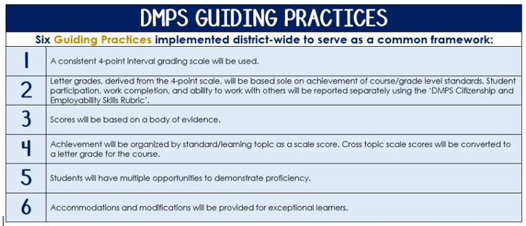
Standards-Referenced Grading Basics
The teacher designs instructional activities and assessments that grow and measure a student’s skills in the elements identified on our topic scales. Each scale features many such skills and knowledges, also called learning targets. These are noted on the scale below with letters (A, B, C) and occur at Levels 2 and 3 of the scale. In the grade book, a specific learning activity could be marked as being 3A, meaning that the task measured the A item at Level 3.

The Body of Evidence in a Process-Based Course
Process-Based SRG is defined as an SRG course design where the same scale recurs throughout the course, but the level of complexity of text and intricacy of task increase over time.

AP Human Geography is a course in which students cycle through focused topics repeatedly as they progress through the course, with changing content and an increasing complexity of the text, analysis, and writing expectations throughout.

To account for this, process-based courses like this have their evidence considered in a “Sliding Window” approach. When determining the topic score for any given grading topic, the most recent evidence determines the topic score. Teacher discretion remains a vital part of this determination, but it is hard to overlook evidence from the most recent (and therefore rigorous) assessments.

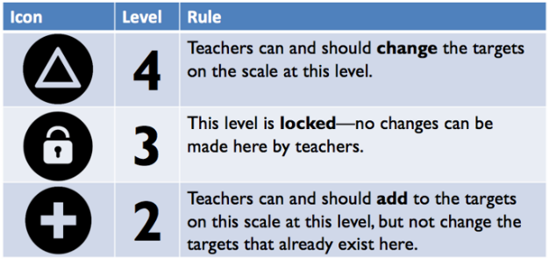
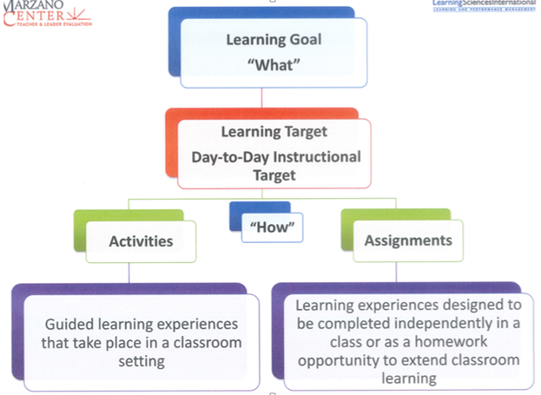

Unit 1: Population and Migration
How is human population organized and how does it shift and change? 6-7 weeks

Enduring Understandings | Suggested Texts and Resources
Students gain an understanding of the ways in which human population is organized geographically and the tools needed to make sense of cultural, political, economic, and urban systems. Students learn about why population is growing or declining in some places and examine trends of fertility, mortality, and migration. This unit enhances students’ understandings of population trends across space and over time by considering models of population growth and decline. Students are in a position to evaluate the strengths and weaknesses of major population policies. | The Cultural Landscape, 10th Edition Chapters 2 and 3  http://wps.prenhall.com/wps/media/access/Pearson_Default/8844/9056971/login.html  National Geography: AP Human Geography Resources  http://education.nationalgeographic.com/education/ap-human-geography/?ar_a=1

Scales
Topic | 4 | 3 | 2
Population Analysis | In addition to meeting the learning goal, the student demonstrates in-depth inferences and applications that go beyond the goal.  Evaluate the historical trends and current projections of population growth and its impact on a regional or global scale. | 3A- Analyze demographic indicators to determine the stages of a country’s development.  3B - Connect population density and distribution to population policies and environmental impacts. | Basic knowledge of concepts in vocabulary:  2A – Demographic Tradition Model, demographic indicators (fertility, mortality, age, sex, income, education, ethnicity)  2B - population density, population distribution (dependency ratio & population pyramids), population policies, environmental impacts
Migration | In addition to meeting the learning goal, the student demonstrates in-depth inferences and applications that go beyond the goal.  Evaluate the consequences of migration (socioeconomic, cultural, environmental, and political) on both a localized and a global scale. | 3A - Explain, with examples, different reasons for migration (push and pull factors).  3B - Describe different types of migration, apply historical and contemporary patterns and examples.  3C - Analyze an immigration policy and its effect (political, social, and economic). | Basic knowledge of concepts in vocabulary:  2A – push and pull factors  2B - types of migration (transnational, internal, chain, step, seasonal, rural, urban, forced, voluntary)  2C – immigration policies (remittances, refugees, asylum seekers, internally displaced persons)

Unit 2: Cultural Patterns and Processes
How does culture impact the world on a local and global scale? 6-7 weeks

Enduring Understandings | Suggested Texts and Resources
Students begin with the concepts of culture and culture traits. They learn how geographers assess the spatial and place dimensions of cultural groups as defined by language, religion, ethnicity, and gender, in the present as well as the past. Students explore cultural interaction at various scales, along with the conflicts that may result. Another important emphasis of the unit is the way culture shapes relationships between humans and the environment. | The Cultural Landscape, 10th Edition Chapters 4-7  http://wps.prenhall.com/wps/media/access/Pearson_Default/8844/9056971/login.html  National Geography: AP Human Geography Resources  http://education.nationalgeographic.com/education/ap-human-geography/?ar_a=1

Scales
Topic | 4 | 3 | 2
Concepts of Culture | In addition to meeting the learning goal, the student demonstrates in-depth inferences and applications that go beyond the goal.  Examine the impact of cultural concepts (list examples) on both a localized and global scale. | 3A – Compare and contrast between acculturation, assimilation, and multiculturalism.  3B - Analyze the effect of colonialism or imperialism on native cultures around the world.  3C – Explain the connection between cultural hearth, diffusion, and the cultural landscape. | Basic knowledge of concepts in vocabulary:  2A – acculturation, assimilation, multiculturalism, ethnocentrism  2B – imperialism, colonialism  2C - diffusion, regions, hearths, cultural landscape, globalization
Cultural Identity and Cultural Differences | In addition to meeting the learning goal, the student demonstrates in-depth inferences and applications that go beyond the goal.  Discuss the ways in which cultural identity and differences can lead to cultural conflict on a regional scale. | 3A - Explain how cultural traits combine to form a cultural identity.  3B – Infer how cultural patterns and landscapes differ by place and region. (Maps) | Basic knowledge of concepts in vocabulary:  2A – dialect, language, cultural identity, lingua franca, ethnicity, religion (universalizing vs. ethnic), cultural traits (such as language, religion, ethnicity)  2B - gender (inequality), sacred space, popular culture, folk culture  cultural protectionism, cultural conflicts, indigenous peoples

Unit 3: Political Organization of Space
In what ways does political organization lead to conflict and/or cooperation? 4-5 weeks

Enduring Understandings | Suggested Texts and Resources
Students are introduced to the nature and significance of the political organization of territory at different scales. Two major themes are the political geography of the modern state and relationships between countries. Students examine political maps and consider some of the forces that are changing the role of individual countries in the modern world, including ethnic separatism, terrorism, economic globalization, and social/environmental problems that cross national boundaries (such as climate change). | The Cultural Landscape, 10th Edition Chapter 8  http://wps.prenhall.com/wps/media/access/Pearson_Default/8844/9056971/login.html  National Geography: AP Human Geography Resources  http://education.nationalgeographic.com/education/ap-human-geography/?ar_a=1

Scales
Topic | 4 | 3 | 2
Political Patterns and Organization | In addition to meeting the learning goal, the student demonstrates in-depth inferences and applications that go beyond the goal.  Demonstrate an understanding of the evolution of contemporary political organization. | 3A - Explain the development and function(s) of international boundaries.  3B - Distinguish between different forms of government and provide an example of each. | Basic knowledge of concepts in vocabulary:  2A – boundaries, sovereignty, nations, states, nation-states, stateless nations, multinational states, multistate nations, autonomous regions, state morphology (shapes of states)  2B – forms of government (federal, unitary); colonialism, imperialism; governance and scale (local, regional)
Cooperation and Conflict | In addition to meeting the learning goal, the student demonstrates in-depth inferences and applications that go beyond the goal.  Discuss factors of political organization that lead to cooperation and conflict on a regional and a global scale. | 3A - Explain examples of success and failure of political cooperation.  3B - Describe the process of devolution of states using a specific example (USSR, Balkans, etc.).  3C – Explain contemporary examples of geopolitical conflict. | Basic knowledge of concepts in vocabulary:  2A – supranationalism, international alliances, fragmentation, unification, cooperation  2B – devolution of countries, centripetal force, centrifugal force  2C – terrorism, armed conflicts  territoriality (heartland, rimland, organic, Laws of the Sea) democratization; redistricting, gerrymandering

Unit 4: Agriculture
In what ways does agriculture influence people’s lives in different regions? 4-5 weeks

Enduring Understandings | Suggested Texts and Resources
Students explore four themes: the origin and diffusion of agriculture; the characteristics and processes of the world’s agricultural production systems and land use; the impact of agricultural changes on quality of life and the environment; and issues in contemporary agriculture. Students examine major agricultural production regions of the world. | The Cultural Landscape, 10th Edition Chapter 10  http://wps.prenhall.com/wps/media/access/Pearson_Default/8844/9056971/login.html  National Geography: AP Human Geography Resources  http://education.nationalgeographic.com/education/ap-human-geography/?ar_a=1  Film Clips: Food Inc., Food Chains

Scales
Topic | 4 | 3 | 2
History, Patterns, and Land Use | In addition to meeting the learning goal, the student demonstrates in-depth inferences and applications that go beyond the goal.  Evaluate the impact of agricultural change on the quality of life and the environment on a regional and global scale. | 3A - Trace the development of agriculture over time.  3B - Explain different types of agricultural patterns in relation to a country’s overall development (LDCs/MDCs).  3C – Compare and contrast how specific agricultural patterns influence land use. | Basic knowledge of concepts in vocabulary:  2A - history of agriculture: agriculture, Neolithic Agricultural Revolution, Second Agricultural Revolution, Green Revolution  2B - agricultural patterns: subsistence, cash cropping, plantation, mixed farming, monoculture, pastoralism, ranching, forestry, fishing, and aquaculture  2C - Von Thunen model; land use (irrigation, desertification, deforestation, wetland destruction, and conservation)
Contemporary Agriculture | In addition to meeting the learning goal, the student demonstrates in-depth inferences and applications that go beyond the goal.  Assess the effect of contemporary agricultural practices on a localized, regional and global scale. | 3A - Compare and contrast industrial and organic farming practices.  3B - Explain, with examples, the impact of contemporary agriculture practices on the environment. | Basic knowledge of concepts in vocabulary:  2A – industrial agriculture, commercial (industrial vs organic) agriculture, agribusiness, genetically modified organisms, biotechnology  2B - environmental issues (soil degradation, overgrazing, water depletion, natural and industrial pollutants); organic farming, crop rotation  fair trade, global food distribution, malnutrition, famine

Unit 5: Industrialization and Economic Development
How does the development of a country or region influence its level of industrialization? 4-5 weeks

Enduring Understandings | Suggested Texts and Resources
Students learn models and measures of economic development to help them understand why the world is divided into a more-developed economic core and a less-developed periphery. Students analyze how countries, regions, and communities are forced to confront new patterns of economic inequity that are linked to geographies of interdependence in the world economy such as international financial crises, consumption patterns, the role of women/children in the labor force, etc. | The Cultural Landscape, 10th Edition Chapters 9 and 11 (12 optional)  http://wps.prenhall.com/wps/media/access/Pearson_Default/8844/9056971/login.html  National Geography: AP Human Geography Resources  http://education.nationalgeographic.com/education/ap-human-geography/?ar_a=1

Scales
Topic | 4 | 3 | 2
Social and Economic Development | In addition to meeting the learning goal, the student demonstrates in-depth inferences and applications that go beyond the goal.  Using the Rostow and/or Wallerstein model, evaluate the economic development of one of the following countries: India, Brazil, Germany, Uganda, or Mexico. | 3A - Explain, with examples, the effects of the Industrial Revolution.  3B - Interpret economic and social indicators to determine the level of development for a country.  3C - Describe a model of economic development (Rostow or Wallerstein). | Basic knowledge of concepts and vocabulary:  2A – Industrial Revolution  2B – economic and social indicators: GDP, GDP per capita, HDI, GII, Gini coefficient (income disparity), social factors (healthcare, education, sanitation, etc.)  2C – models of economic development: Rostow, Wallerstein
Industrialization and Impacts | In addition to meeting the learning goal, the student demonstrates in-depth inferences and applications that go beyond the goal.  Assess how economic restructuring is transforming the world economy. Use examples from both a regional and global scale. | 3A - Apply Weber’s model to an industry.  3B – Explain, with examples, the economic sectors that make up the world economy.  3C - Analyze the political, social and environmental effects of industrialization. | Basic knowledge of concepts and vocabulary:  2A – geographic models of industry, Weber, bid rent  2B – international division of labor: primary, secondary, tertiary, quaternary, quinary  2C – deindustrialization, resource depletion, sustainability, women and children in the workforce; government development initiatives (local, regional, national)

Unit 6: Cities and Urban Land Use
Why are cities located and organized the way that they are? 3-4 weeks

Enduring Understandings | Suggested Texts and Resources
Students study the systems of cities, focusing on where cities are located and why they are there. This involves exploring topics such as the distribution of cities; the political, economic, and cultural functions of cities; reasons for growth among cities; and types of transportation and communication linkages among cities. Students also examine the form, internal structure, and landscapes of cities and what cities are like as places in which to live and work. Topics such as urban land use, ethnic segregation, transportation, architecture, the environmental impact, and trends in urban development are explored. | The Cultural Landscape, 10th Edition Chapter 13  http://wps.prenhall.com/wps/media/access/Pearson_Default/8844/9056971/login.html  National Geography: AP Human Geography Resources  http://education.nationalgeographic.com/education/ap-human-geography/?ar_a=1

Scales
Topic | 4 | 3 | 2
Urban Development and Models | In addition to meeting the learning goal, the student demonstrates in-depth inferences and applications that go beyond the goal.  How do urban spaces grow? Discuss their development on a local, regional, and global scale.  Use models of urban development to demonstrate understandings. | 3A - Trace the origin and development of modern cities using the level two vocabulary.  3B - Compare and contrast two of the following models of urban development: Burgess, Hoyt, Harris and Ullman and Galactic.  3C - Apply the gravity model or central place theory to a current business or service. | Basic knowledge of concepts and vocabulary:  2A – origins of cities; site and situation characteristics, urbanization, suburbanization, megacities, world cities, Borchert  2B – models of urban development: rank-size rule vs. primate cities, Burgess concentric zone model, Hoyt sector model, Harris and Ullman multiple nuclei model, Galactic city model; international models  2C – gravity model, Christaller’s central place theory
Urban Issues and Challenges | In addition to meeting the learning goal, the student demonstrates in-depth inferences and applications that go beyond the goal.  Design a city. Use 1 or 2 urban models to justify the city’s design. | 3A - Describe factors that influence urban planning and design.  3B - Explain, with examples, contemporary urban issues. | Basic knowledge of concepts and vocabulary:  2A – urban planning and design: types of residential buildings, infrastructure, transportation, political organization, diversity of urban spaces, edge cities  2B – contemporary urban issues: discrimination, access to food, employment, social structures, gentrification, suburban sprawl, urban sustainability, urban environmental issues

Reoccurring Standards 2016-17

Scales
Topic | 4 | 3 | 2
Writing Informative Text  Semester 1 and 2 | In addition to meeting the learning goal, the writing goes beyond the grade level expectation by connecting the information to one or more of the following:  -a development from a different time period, scale, or geographical area  -a link to a course theme or approach to geography that is not the focus of the writing (such as political, economic, social, cultural geography). | 3A - Address all parts of the prompt  3B - Organize ideas and concepts (chronologically or thematically)  3C – Accurately develops the topic with relevant facts, evidence, and extended definitions of content-specific terminology that are appropriate to the prompt | A level 2 writing sample fails to meet the learning goal in two areas:  -Introduction addresses part of the prompt  -Organization of concepts is attempted  -Some use of relevant evidence

AP Readiness: Geographic Skills

Scales
Topic | 4 | 3 | 2
Geographic Skills | In addition to meeting the learning goal, map themes are interpreted and discussed using content-specific vocabulary. | Accurately label and/or interpret maps at different scales. | Attempts to label and/or interpret maps at different scales with at least 50% accuracy.

 | Topic:  AP-Style Assessments | AP Exam  Score Conversion
4 | In addition to meeting the learning goal, the student demonstrates in-depth inferences and applications that go beyond the goal. | 90-100%
3.5 | Student’s performance reflects exceptional facility with some, but not all Level 4 learning targets. | 80-89%
3  Learning Goal | Student’s performance reflects success on all Level 3 learning targets. | 70-79%
2.5 | Student’s performance reflects success on some, but not all, Level 3 learning targets | 60-69%
2 | Student’s performance reflects success on all Level 2 learning targets. | 50-59%
1.5 | Student’s performance reflects success on some but not all Level 2 learning targets | 40-49%
1 | Student’s performance reflects insufficient progress towards foundational skills and knowledge. | 20-39%

