The Des Moines Public Schools Curriculum guide contains the prioritized standards, required pacing, materials and resources, and assessment correlates for the school year. This document is intended to be used in conjunction with our balanced assessment plan to scaffold our students in mastery of the Iowa Core State Standards.
AP US History: Des Moines Public Schools
2018-2019 CURRICULUM GUIDE SOC501/502

AP United States History
The AP United States History course is equivalent to an introductory college-level course in U.S. history. This course develops students’ abilities to think conceptually about U.S. history from approximately 1491 to the present and apply historical thinking skills as they learn about the past. Seven themes of equal importance – identify; peopling; politics and power; work, exchange, and technology; America in the world; environment and geography; and ideas, beliefs, and culture – provide areas of historical inquiry for investigation throughout the course. These require students to reason historically about continuity and change over time and make comparison among various historical developments in different times and places.

AP United States History – Course Content:
• Period 1: 1491-1607 • Period 2: 1607-1754 • Period 3: 1754-1800 • Period 4: 1800-1848
• Period 5: 1844-1877 • Period 6: 1865-1898 • Period 7: 1890-1945 • Period 8: 1945-1980
• Period 9: 1980-Present

AP United States History – Historical Thinking Skills:
• Chronological Reasoning
• Comparison and Contextualization
• Crafting Historical Arguments from Historical Evidence
• Historical Interpretation and Synthesis

AP United States History Exam
The AP United States History Exam measures students’ knowledge of U.S. history and their ability to think historically.
Format of Assessment
Section I Part A: Multiple Choice | 50-55 Questions | 55 Minutes | 40% of Exam Score
• Questions appear in sets of 2-5 • Students analyze historical texts, interpretations, and evidence • Primary and secondary sources, images, graphs, and maps are included
Section I Part B: Short Answer | 3 Questions | 35 Minutes | 20% of Exam Score
• Questions provide opportunities for students to demonstrate what they know best • Some questions include texts, images, graphs, or maps
Section II Part A: Document-Based | 1 Question | 65 Minutes | 25% of Exam Score
• Analyze and synthesize historical data • Assess written, qualitative, or visual materials as historical evidence
Section II Part B: Long Essay | 1 Question | 40 Minutes | 15% of Exam Score
• Students select one of two questions • Explain and analyze significant issues in U.S. History • Develop an argument supported by an analysis of historical evidence

Link to DMPS Grading Resources: http://grading.dmschools.org
Link to Course Resources: http://socialstudies.dmschools.org/electives.html
Link to Course Information @ AP Central: https://advancesinap.collegeboard.org/english-history-and-social-science/us-history
Topic | Standards | Topic | Standards
Periods  1 and 2 | 9-12.H.1 Understand historical patterns, periods of time, and the relationships among these elements.  9-12.H.8 Understand cause and effect relationships and other historical thinking skills in order to interpret events and issues. | Period 6 | 9-12.H.3 Understand the role of culture and cultural diffusion on the development and maintenance of societies.  9-12.H.5 Understand the effect of economic needs and wants on individual and group decisions.  9-12.H.6 Understand the effects of geographic factors on historical events.  9-12.H.7 Understand the role of innovation on the development and interaction of societies.
Period 3 | 9-12.H.2 Understand how and why people create, maintain, or change systems of power, authority, and governance.  9-12.H.4 Understand the role of individuals and groups within a society as promoters of change or the status quo. | Period 7 | 9-12.H.1 Understand historical patterns, periods of time, and the relationships among these elements.  9-12.H.8 Understand cause and effect relationships and other historical thinking skills in order to interpret events and issues.
Period 4 | 9-12.H.3 Understand the role of culture and cultural diffusion on the development and maintenance of societies.  9-12.H.5 Understand the effect of economic needs and wants on individual and group decisions.  9-12.H.6 Understand the effects of geographic factors on historical events.  9-12.H.7 Understand the role of innovation on the development and interaction of societies. | Period 8 | 9-12.H.2 Understand how and why people create, maintain, or change systems of power, authority, and governance.  9-12.H.4 Understand the role of individuals and groups within a society as promoters of change or the status quo.9-12.H.8 Understand cause and effect relationships and other historical thinking skills in order to interpret events and issues.
Period 5 | 9-12.H.1 Understand historical patterns, periods of time, and the relationships among these elements.  9-12.H.8 Understand cause and effect relationships and other historical thinking skills in order to interpret events and issues. | Period 9 | 9-12.H.1 Understand historical patterns, periods of time, and the relationships among these elements.  9-12.H.8 Understand cause and effect relationships and other historical thinking skills in order to interpret events and issues.
Analyzing Multiple Sources | RH.11-12.9. Integrate information from diverse sources, both primary and secondary, into a coherent understanding of an idea or event, noting discrepancies among sources. | Document-Based Question  Long-Essay Question | RH.11-12.9. Integrate information from diverse sources, both primary and secondary, into a coherent understanding of an idea or event, noting discrepancies among sources.  9-12.W.1 Write arguments to support claims in an analysis of substantive topics or texts, using valid reasoning and relevant and sufficient evidence.  9-12.W.2 Write informative/explanatory texts to examine and convey complex ideas, concepts, and information clearly and accurately through the effective selection, organization, and analysis of content.

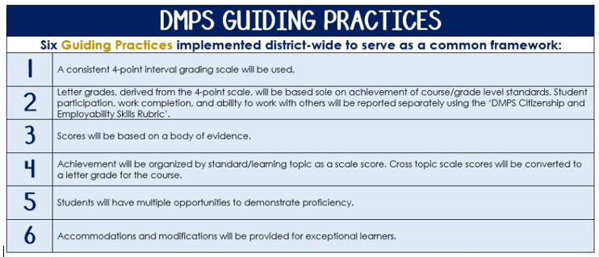
Standards-Referenced Grading Basics
The teacher designs instructional activities and assessments that grow and measure a student’s skills in the elements identified on our topic scales. Each scale features many such skills and knowledges, also called learning targets. These are noted on the scale below with letters (A, B, C) and occur at Levels 2 and 3 of the scale. In the grade book, a specific learning activity could be marked as being 3A, meaning that the task measured the A item at Level 3.

The Body of Evidence in a Process-Based Course
Process-Based SRG is defined as an SRG course design where the same scale recurs throughout the course, but the level of complexity of text and intricacy of task increase over time.

AP United States History cycles students through some topics repeatedly as they progress through the course, with changing content and an increasing complexity of the text, analysis, and writing expectations throughout.

To account for this, process-based courses like this have their evidence considered in a “Sliding Window” approach. When determining the topic score for any given grading topic, the most recent evidence determines the topic score. Teacher discretion remains a vital part of this determination, but it is hard to overlook evidence from the most recent (and therefore rigorous) assessments.

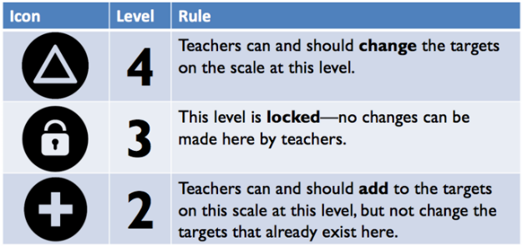
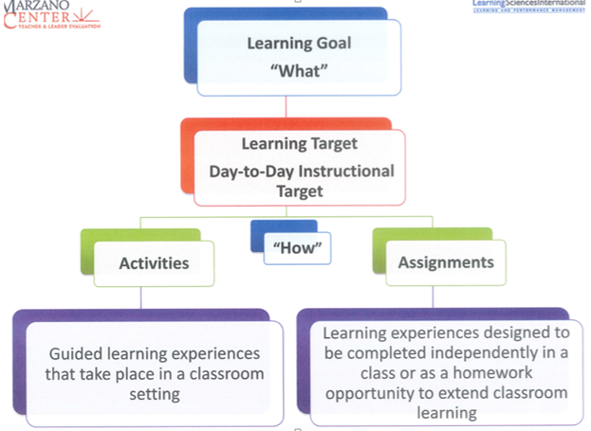

AP United States History Course Topics – Semester 1
Text and Resources
Give Me Liberty! An American History, 3rd Edition. Eric Foner
Textbook Online: http://www.wwnorton.com/college/history/give-me-liberty3-brief/
AP Teacher Community: https://apcommunity.collegeboard.org/web/apushistory
AP Teacher Resources (College Board): https://advancesinap.collegeboard.org/english-history-and-social-science/us-history/us-history-resources
Gilder Lehrman AP Study Site: ap.gilderlehrman.org
PBS: Crash Course Video Clips: http://www.pbslearningmedia.org/collection/crash-course/?topic_id=1855

Scales
Topic | 4 | 3 | 2
Analyzing Multiple Sources | In addition to meeting the learning goal, the response assesses the reliability, usefulness, or limitations of a source. | Both documents are used as evidence and analyzed by including one or more of the following:  - Author’s point of view  - Purpose of the document  - Intended audience  - Historical context | Uses documents as evidence, but fails to analyze the documents by unpacking author’s point of view, purpose of the document, intended audience, or historical context.
Topic | 4 | 3 | 2
Periods 1 and 2  (Unit 1) | In addition to meeting the learning goal, the student demonstrates in-depth inferences and applications that go beyond the goal.  Tie these to 1 of the 4 historical thinking skills | 3A – Describe Native American cultures before and following European contact and explain the impact of the Columbia Exchange.  3B - Compare and Contrast the New World goals of Spain, France, and England.  3C – Differentiate between the development of the New England, Chesapeake, and Southern Colonies and describe how the British exerted their control over them. | 2A - Great Basin/Great Plains, hunter gatherer, Christianity, feudalism, capitalism, joint stock company, encomienda system, slavery, the Columbian Exchange  2B - New England, Middle, Chesapeake, Southern colonies, indentured servitude  2C - Enlightenment, Atlantic Trade, Great Awakening, Pueblo Revolt, mercantilism
Topic | 4 | 3 | 2
Period 3  (Unit 2) | In addition to meeting the learning goal, the student demonstrates in-depth inferences and applications that go beyond the goal. | 3A- Investigate the significance of the events that led to the American Revolution.  3B-Predict the outcome of America’s early attempts at Republican government, and determine how those issues were resolved.  3C-Assess America’s ability to deal with challenges associated with geographic, economic, and political expansion. | 2A – Patriot/Loyalist, Continental Army, George Washington, Thomas Paine’s Common Sense, Declaration of Independence  2B – ‘republican motherhood, Articles of Confederation, Constitutional Convention, Federalists/Anti-Federalists. Federalist Papers, U.S. Constitution, Bill of Rights, Thomas Jefferson, James Madison, Alexander Hamilton  2C - Democratic Republicans. Northwest Ordinance, Washington’s Farewell Address
Topic | 4 | 3 | 2
Period 4  (Unit 3) | In addition to meeting the learning goal, the student demonstrates in-depth inferences and applications that go beyond the goal. | 3A- Explain how an increase in political involvement led to the creation of cultural identities, and social activism.  3B- Evaluate how economic, and technological growth led to an expansion of regional and national identities.  3C- Describe how geographical and economic expansion lead to a rise of sectionalism and cultural tensions in America. | 2A – tariff, Andrew Jackson, Democrats, immigration (German, Irish, Chinese), 2nd Great Awakening, abolition, Seneca Falls Convention  2B – Louisiana Purchase, Monroe Doctrine, Market Revolution, American System, Henry Clay  2C – nullification, Missouri Compromise
Topic | 4 | 3 | 2
Period 5  (Unit 4) | In addition to meeting the learning goal, the student demonstrates in-depth inferences and applications that go beyond the goal. | 3A- Trace the development of America’s “Manifest Destiny” and how it contributed to political tension, and social inequalities that led to a Civil War.  3B- Evaluate to what extent the Civil War and Reconstruction resolved the issues of political tensions, and social inequalities in America. | 2A – Manifest Destiny, Mexican American War, Mexican Cession, Compromise of 1850, Kansas-Nebraska Act, Dred Scott, Republican Party (Second Party System)  2B – secession, Civil War, Abraham Lincoln, Emancipation Proclamation, Gettysburg, 13th, 14th, 15th Amendment, Reconstruction, Black Codes, share cropping

AP United States History Course Topics – Semester 2
Text and Resources
Give Me Liberty! An American History, 3rd Edition. Eric Foner AP Teacher Community: https://apcommunity.collegeboard.org/web/apushistory
Gilder Lehrman AP Study Site: ap.gilderlehrman.org
PBS: Crash Course Video Clips: http://www.pbslearningmedia.org/collection/crash-course/?topic_id=1855

Scales
Topic | 4 | 3 | 2
Period 6  (Unit 5) | In addition to meeting the learning goal, the student demonstrates in-depth inferences and applications that go beyond the goal. | 3A-Determine the causes of American industrialization and explain the social and political reforms that progressives used to curb the inequalities of the Gilded Age.  3B- Describe how mass migration contributed to a rise in urbanization and the eventual closing of the frontier.  3C - Describe the political and social problems that developed during the Gilded Age and how progressives responded to those problems. | 2A – laissez-faire, consolidation/trusts, industrialization, The New South  2B – “new” vs “old” immigrants, Ellis Island, Transcontinental Railroad, Americanization, nativism  2C – urbanization, standard of living, “the gap”, Social Darwinism, Gospel of Wealth, Social Gospel, Jane Addams, Plessy v. Ferguson, political machines, bosses, Populist Party
Topic | 4 | 3 | 2
Period 7  (Imperialism and WWI) | In addition to meeting the learning goal, the student demonstrates in-depth inferences and applications that go beyond the goal. | 3A- Debate the merits of America’s move towards imperialism in the late 19th Century.  3B- Explain the reasoning behind America’s decision to go from neutrality to war, and back to neutrality and describe the effects those decisions had on our citizens. | 2A – imperialists vs anti-imperialists, Spanish-American War  2B – isolationism, fascism, mobilization, militarism, the Great Migration, The League of Nations, Woodrow Wilson, Fourteen Points
Topic | 4 | 3 | 2
Period 7  (Interwar Years and WWII) | In addition to meeting the learning goal, the student demonstrates in-depth inferences and applications that go beyond the goal. | 3A- Describe the clash between traditionalism and modernism that developed during the 1920ss.  3B- Identify the economic changes of the 1920’s that led to a financial crisis and evaluate the extent to which the New Deal permanently changed the relationship between the government and its people.  3C- Explain the need for American participation in WWII and describe the positive and negative effects the war had on its citizens. | 2A – prohibition, women’s movement, evolution debate, First Red Scare, Harlem Renaissance  2B – Franklin Roosevelt, The New Deal, deficit spending, alphabet soup  2C – domestic policy, foreign policy
Topic | 4 | 3 | 2
Period 8  (Unit 7) | In addition to meeting the learning goal, the student demonstrates in-depth inferences and applications that go beyond the goal. | 3A- Trace the development of Cold War foreign policy from the development of atomic power to the collapse of communism.  3B- Evaluate how social movements initiated domestic changes in American society.  3C- Explain how social movements caused political shifts between liberalism and conservatism between 1945-1980. | 2A – containment, communism, democracy, Cold War, proxy wars, Korea, Vietnam  2B – civil rights, nonviolent resistance, militancy, MLK Jr., Brown v. Board of Education, Civil Rights Act of 1964, Voting Rights Act of 1965, feminism, Chicano movement, AIM, gay/lesbian movements, counterculture, Evangelical activism  2C – conservatism v. liberalism, Kennedy (New Frontier), Johnson (Great Society), Nixon, etc., conservatism, Ronald Reagan, George H.W. Bush, Clinton, George W. Bush, trickle-down economics, globalization, NAFTA
Topic | 4 | 3 | 2
Period 9  (Unit 8) | In addition to meeting the learning goal, the student demonstrates in-depth inferences and applications that go beyond the goal. | 3A -Trace the development of interventionism in American foreign policy from the end of the Cold War to the modern day. | The student demonstrates the ability to recognize/ recall:  2A – Cold War, détente, Berlin Wall, Persian Gulf War, September 11
Topic | 4 | 3 | 2
Document-Based Question | In addition to meeting the learning goal, the long essay response, distinguishes the historical interpretation from opposing interpretations using prior knowledge or acknowledges that the situation is nuanced and to some degree ambiguous. | 3A – State a relevant thesis that addresses all parts of the question.  3B – Support the thesis by using historical evidence in an organized, cohesive way.  3C – Support the thesis with evidence from all, or all but one, of the documents.  3D – Support the thesis with analysis of historical evidence outside the documents.  3E – Connect historical themes relevant to your argument to broader events or processes (contextualization). | A level 2 document-based question fails to meet the learning goal in two areas:  2A – Thesis  2B – Organization  2C - Use of documents as evidence  2D - Use of historical examples and evidence outside the documents  2E - Attempts to connect historical themes to broader events and processes
Topic | 4 | 3 | 2
Argumentation  (Long Essay Question) | In addition to meeting the learning goal, the long essay response, distinguishes the historical interpretation from opposing interpretations using prior knowledge or acknowledges that the situation is nuanced and to some degree ambiguous. | 3A - Develop a relevant thesis  3B - Organize claim(s) and evidence (chronologically, thematically, etc.).  3C –Support, modify, or refute a historical interpretation with relevant and accurate historical facts, evidence, and examples.  3D –Support, modify, or refute a historical interpretation through the analysis of selected historical facts, evidence, and examples. | A level 2 long essay response fails to meet the learning goal in two areas:  2A - Begins to develop a thesis  2B - Organization of concepts is attempted  2C - Some use of historical facts, evidence, and examples, may be inaccurate or irrelevant  2D - Some analysis of selected historical facts, evidence, and examples, may be inaccurate or irrelevant

 | Topic:  Periods of Time - AP-Style Assessments | AP Exam  Score Conversion
4 | In addition to meeting the learning goal, the student demonstrates in-depth inferences and applications that go beyond the goal. | 90-100%
3.5 | Student’s performance reflects exceptional facility with some, but not all Level 4 learning targets. | 80-89%
3  Learning Goal | Student’s performance reflects success on all Level 3 learning targets. | 70-79%
2.5 | Student’s performance reflects success on some, but not all, Level 3 learning targets | 60-69%
2 | Student’s performance reflects success on all Level 2 learning targets. | 50-59%
1.5 | Student’s performance reflects success on some but not all Level 2 learning targets | 40-49%
1 | Student’s performance reflects insufficient progress towards foundational skills and knowledge. | 20-39%

 | Topic:  Document-Based Question Essays | DBQ Score Conversion
4 | In addition to meeting the learning goal, the long essay response, distinguishes the historical interpretation from opposing interpretations using prior knowledge or acknowledges that the situation is nuanced and to some degree ambiguous. | 7
3.5 | Student’s performance meets all of the learning goal and hit some of the Level 4 learning targets. | 6
3  Learning Goal | Students demonstrate they have the ability to:  3A – State a relevant thesis that addresses all parts of the question.  3B – Support the thesis by using historical evidence in an organized, cohesive way.  3C -- Support the thesis with evidence from all, or all but one, of the documents.  3D – Support the thesis with analysis of historical examples outside the documents.  3E – Connect historical themes relevant to your argument to broader events or processes (contextualization). | 5
2.5 | Student’s performance reflects success on some but not all Level 3 learning targets. | 4
2 | A level 2 document-based question fails to meet the learning goal in two areas:  2A - Thesis  2B - Organization  2C - Use of documents as evidence  2D - Use of historical examples and evidence outside the documents  2E - Attempts to connect historical themes to broader events and processes | 3
1.5 | Student’s performance reflects success on some but not all Level 2 learning targets. | 2
1 | Student’s performance reflects insufficient progress towards foundational skills and knowledge. | 1

 | Topic:  Long Essay Questions for AP | LEQ Score Conversion
4 | In addition to meeting the learning goal, the long essay response, distinguishes the historical interpretation from opposing interpretations using prior knowledge or acknowledges that the situation is nuanced and to some degree ambiguous. | 6
3.5 | Student’s performance reflects exceptional facility with untimed but not timed argument writing. | 5
3  Learning Goal | Students demonstrate they have the ability to:  3A - Develop a relevant thesis  3B - Organize claim(s) and evidence (chronologically, thematically, etc.).  3C - Support, modify, or refute a historical interpretation with relevant and accurate historical facts and evidence.  3D - Support, modify, or refute a historical interpretation through the analysis of selected historical facts and evidence. | 4
2.5 | Student’s performance reflects success on some but not all Level 3 learning targets. | 3
2 | A level 2 long essay response fails to meet the learning goal in two areas:  2A - Begins to develop a thesis  2B - Organization of concepts is attempted  2C - Some use of historical facts, evidence, and examples, may be inaccurate or irrelevant  2D - Some analysis of selected historical facts, evidence, and examples, may be inaccurate or irrelevant | 2
1.5 | Student’s performance reflects success on some but not all Level 2 learning targets. | 1
1 | Student’s performance reflects insufficient progress towards foundational skills and knowledge. | 1

